TabBar

MainTabBarController

Subclass: UITabBarController, UITabBarControllerDelegate

1. viewDidLoad //override func
   1. view.backgroundColor = .red
   2. delegate = self
   3. setupTabBarViewController()

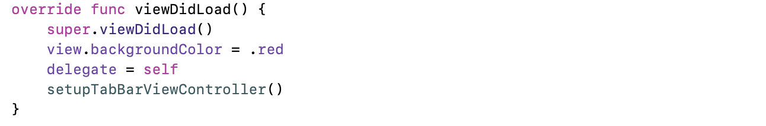

1. setupTabBarViewController //func
   1. tabBar.tintColor = .black
   2. let xxNavController = templateNavController() //custom func
   3. viewControllers = [xxNavController, …, xxNavController]
   4. adjust icons position

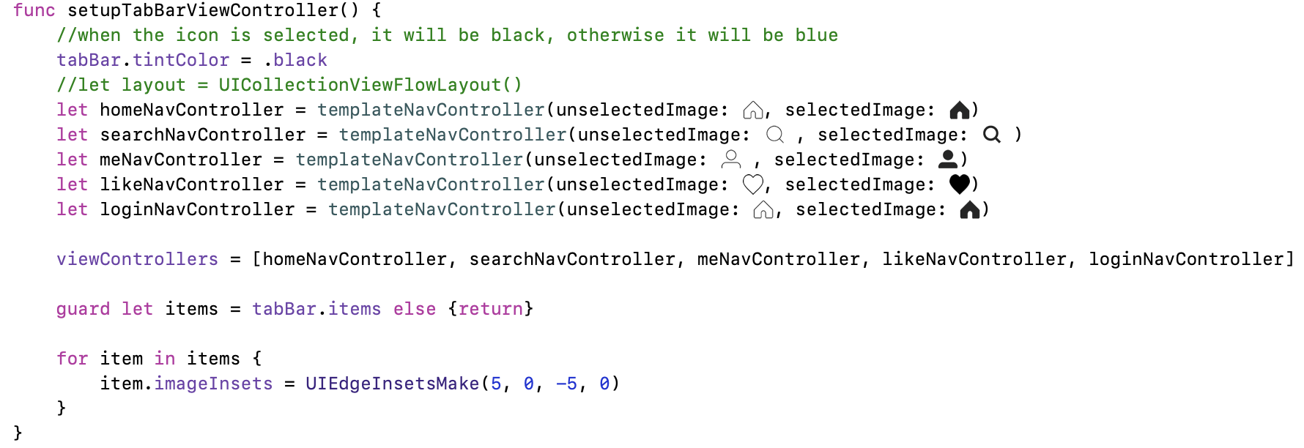

1. templateNavController(unselectedImage: UIImage, selectedImage: UIImage, rootViewController: UIViewController = UIViewController()) -> UINavigationController

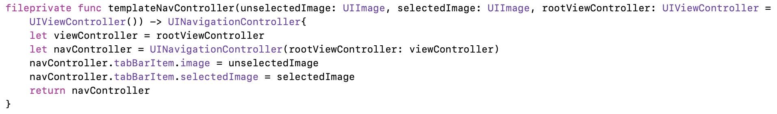

Overall

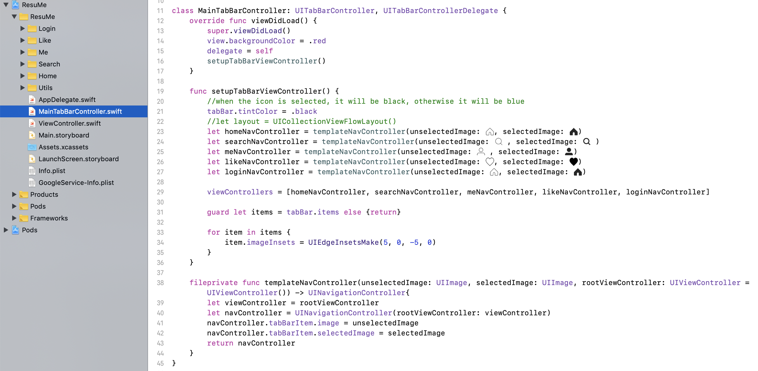

AppDelegate

1. window = UIWindow()
2. window?.rootViewController = MainTabBarController()

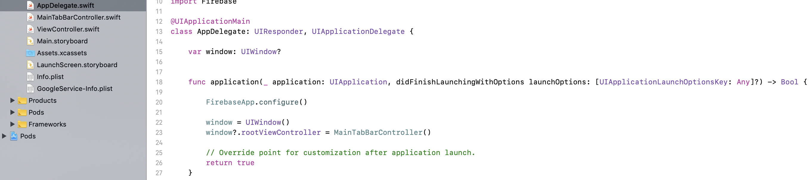



Collection View

CollectionViewController

Subclass: UICollectionViewController, UICollectionViewDelegateFlowLayout

1. viewDidLoad
   1. collectionView?.backgroundColor = .white

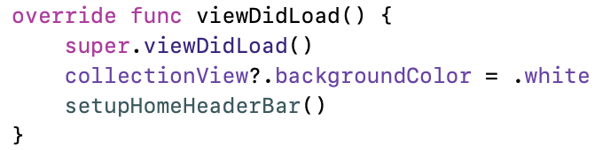

1. numberOfItem



1. numberOfSections // One section only has one header and one footer

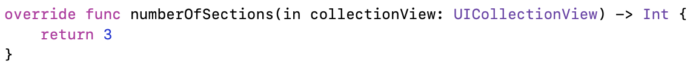

1. cellForItemAt
   1. // test version
      1. collectionView.register( [UICollectionViewCell.self], …)
      2. cell.backgroundColor = .yellow
   2. // implement version
      1. collectionView.register( [xxx.self], …)
   3. let cell = collectionView.dequeueReuseableCell(…)

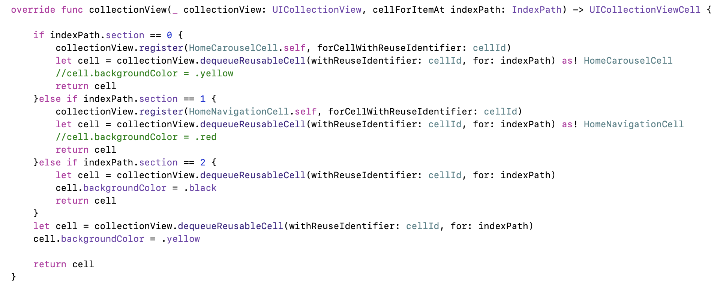

1. sizeForItemAt

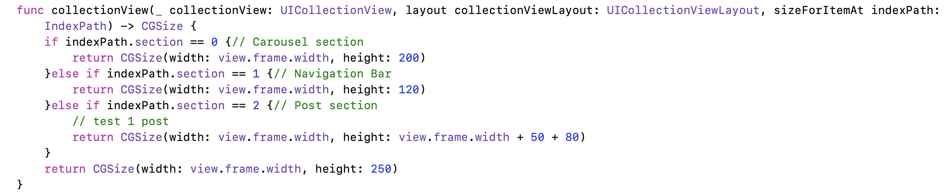

1. header/footer
   1. viewForSupplementryElementOfKind
      1. let header = collectionView.dequeueReusableSupplementary



* 1. refsizeheader or refsizefooter



CollectionViewCell

Subclass: UICollectionViewCell

1. init
   1. addSubview
   2. adjust postion methods (Extention of UIView)
      1. xx.anchor
      2. xx.fillSuperview
      3. xx.anchorCenterSuperview
      4. xx.anchorCenterXToSuperview
      5. xx.anchorCenterYToSuperview
      6. anchorWithReturnAnchors

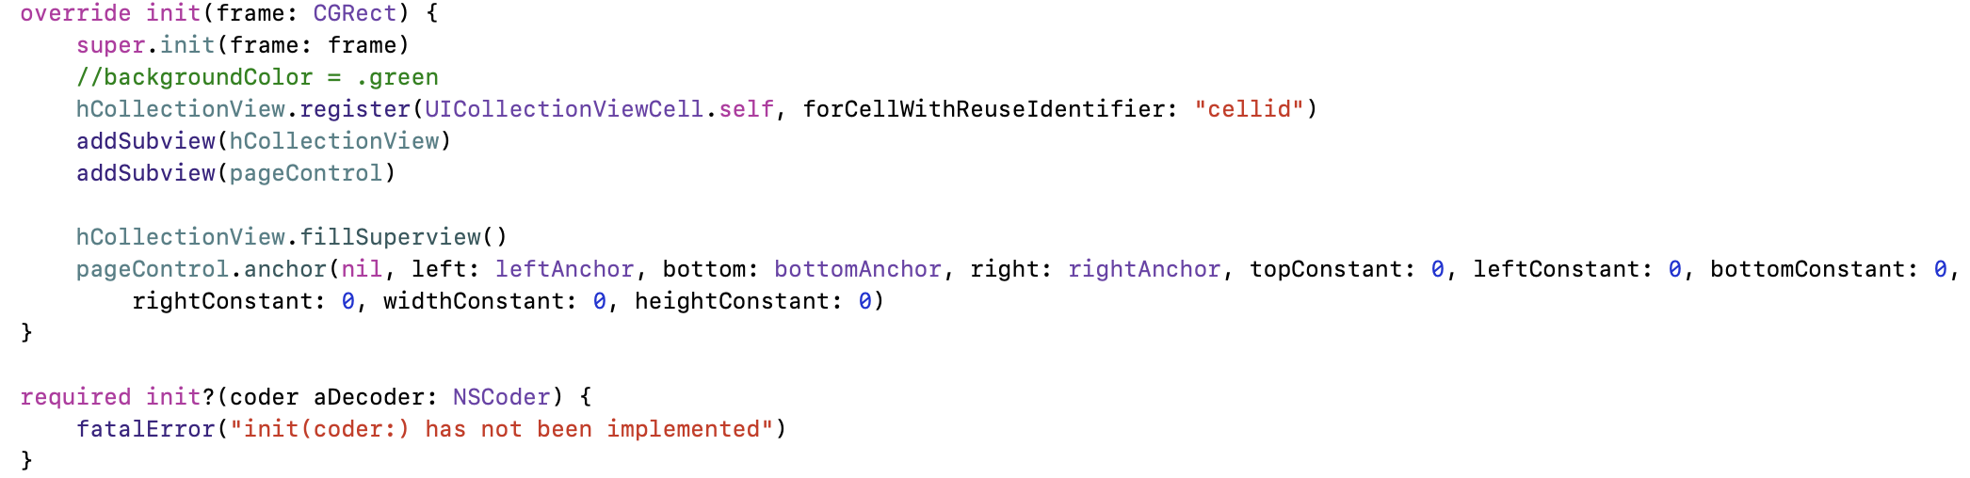

1. customCell
   1. A CollectionView in a CollectionViewCell
      1. Subclass: BaseCell, UICollectionViewDelegateFlowLayout, UICollectionViewDataSource, UICollectionViewDelegate



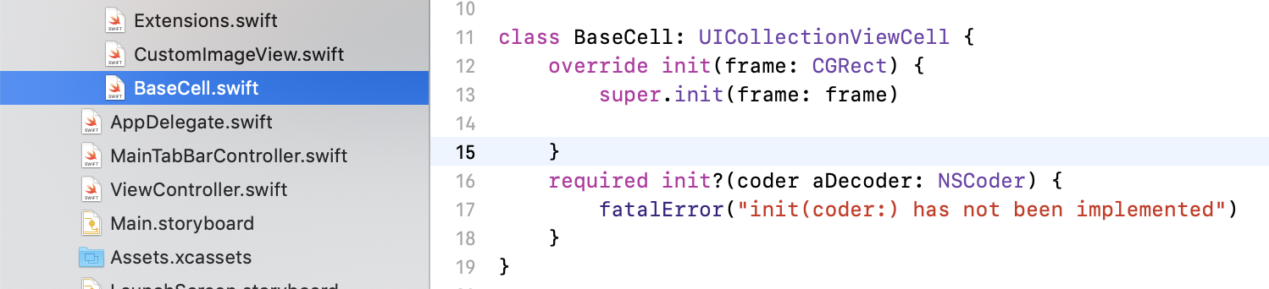

* + 1. Create CollectionView Object

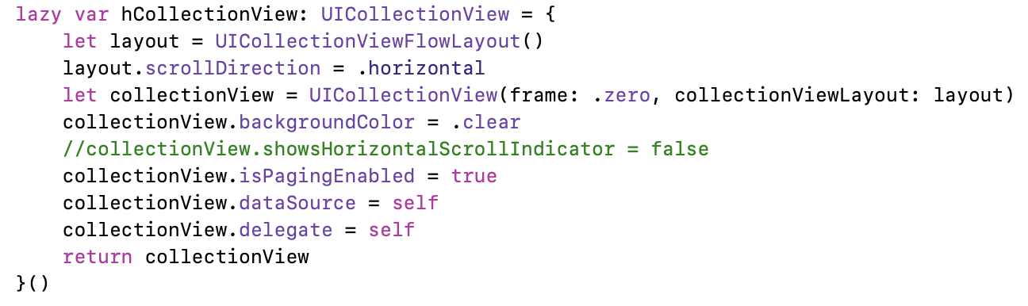

* + 1. numberOfItems
    2. cellForItemAt
    3. sizeForItemAt
  1. minimize gaps
     1. miniLineSpacing



* + 1. miniIterItem



* + 1. insetForSection

Short cuts

1. Create a file -> command + n
2. Run app -> command + r
3. Build app -> command + b
4. Fold method/class -> option + command + <-
5. Go to AppDelegate.swift file

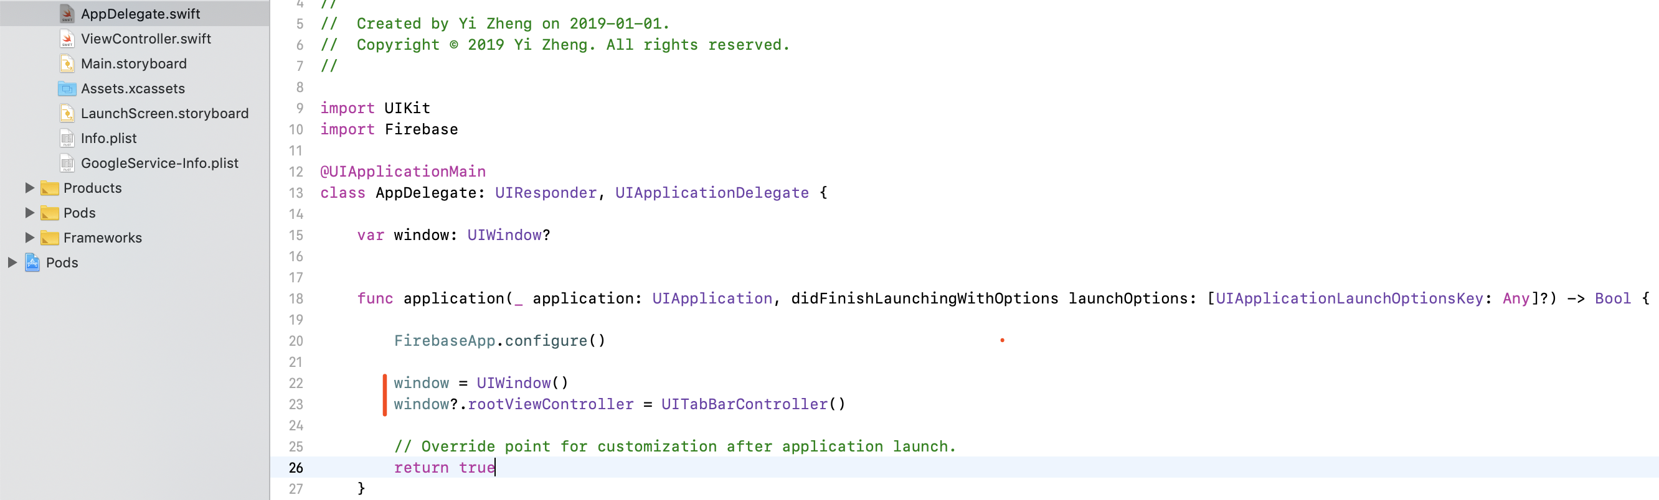

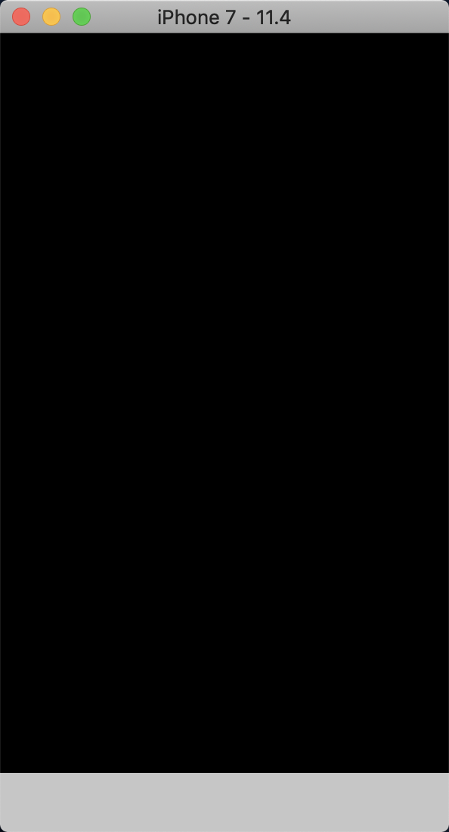

1. Create MainTabBarController.swift file

subclass: UITabBarController, UITabBarControllerDelegate

* 1. Import UIKit
  2. Add viewDidLoad
  3. In AppDelegate.swift:
     1. Add “window = UIWindow()/ window?.rootViewController = MainTableBarController()”

